Actions
Who | What | By when
All | Review the agreed principles and email Claire stating whether you agree or would like to see changes. | 25th October 2018
All | All to look through the slides on R groups and send round your thoughts. | 25th October 2018
All | Email Claire details of commonly used or recommended amino acid naming conventions. | 25th October 2018

Attendees
CAS | Matthew Dunbar (CAS)
Carnegie-Mellon University | Dave Yaron
EBI | Ann Gaulton
Lille University | Maude Pupin
Lilly | Kent Holaday
NextMove | Roger Sayle
Novartis | Yohann Potier
Pfizer | Tianhong Zhang
 | Sergio Rotstein
Pistoia Alliance | Claire Bellamy
PubChem | Evan Bolton
Sciligence | Tony Yuan

Agenda
Peptide
- Substitutions
- R groups
Future topics
Next steps

Peptide diversity and exploding monomer sets
The notes below capture the key questions and comments. See slides for the topic background and questions.

Principles (tentatively) agreed
HELM should use capping monomers for C and N terminal substitutions. i.e.
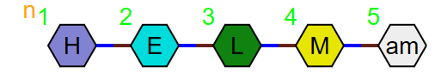 and not 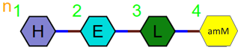
Capping monomers should be the same polymer type as the main chain of the polymer they are a part of to keep the HELM string as readable as possible.
All other types of monomer: i.e. non-terminal N substitutions and substitutions elsewhere on the amino acid, L, D and positional isomers should be defined as new monomers.
- We will not define a new branch type monomer to handle peptide substitutions.

Action: Please consider the implications of these principles and email round comments if you find difficulties that we did not discuss, and you believe we should consider.

Comments and issues
You can have same monomer structure defined as different monomers if those monomers are different polymer types. When using - the user should select the one most appropriate to the context to help readability.
Large monomer sets are not necessarily a problem if they can be sorted in a way that makes navigation easy. For example, can you say: give me all the L forms or N substituted forms?
Naming will be critical to facilitate navigation of the monomer set.
Different R groups will be required for N and C terminal positions.
We should use statistics to identify the most common monomers, so any core set is focussed on the most frequently used. (post meeting question – should infrequent monomers be defined using in-line HELM?). Groups can then use the best practice rules for additions to this set as they need to.

R groups
Action: All to look through the slides on R groups and send round your thoughts.

Next Steps
Action: Let Claire know if you have a suggestion for a naming convention for peptides.

